Contents
Logging into SAS studio 2
Logging out 3
Open program 3
Working with SAS studio 8
Making a (sub)directory for your work / project 8
Finding the path on the server to a directory (to refer/save files with a libname statement) 8
Uploading to directories and downloading files 10
Option 1: Via the buttons in the upper left 10
Option 2: Right-click: 10
Reading a data source (Excel, SPSS, STATA, …) into SAS 11
Permanent SAS dataset after reading it from a data source (Excel, SPSS, STATA, …) 13
Referring to directories (for data or format libraries) using library names 17
Making a new program 18
Via the folder and righ click: 18
via the right panel and right click: 18
via pressing F3 18
Running a program and seeing the output 19
Hiding and unhiding the left panel (with Server Files and Folders, Libraries etc). 19
Program, Log, Results window open next to each other 19
Creating pdf, rtf output or figures (these can be downloaded as indicated above) 20
Making comments within a program (comments are not executed) 21
Shortcuts 21

Logging into SAS studio

- Log in at https://welcome.oda.sas.com/
  - with sas user id: u64569023
  - and password: S@S_1s_0nl1n3
  - and check the “Accept the terms …. “
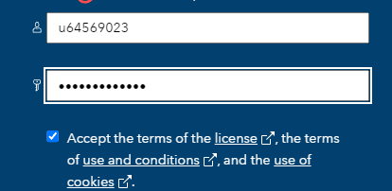
  - And sign in.
- Then launch SAS Studio with the *Launch* button.
You will see something like the following: 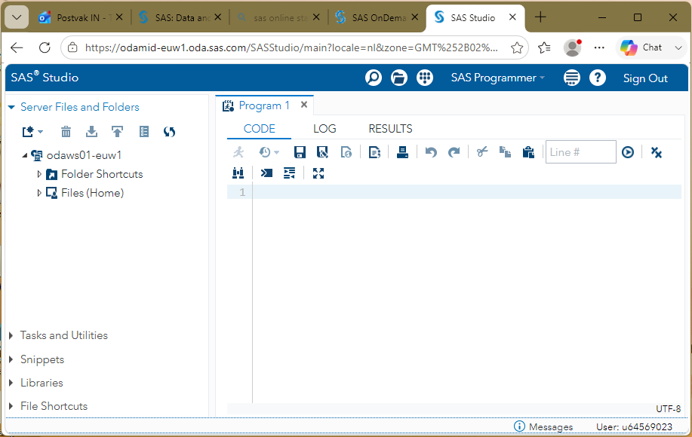

- You can see your username in SAS studio
  - when you point (“hoover”) the mouse on the “Sign Out”:
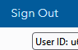
  - or on the bottom right in SAS studio

Logging out
You first log out of SAS studio (top right) and
then another time log out from your SAS profile (top right where your name is stated, take the pull down menu)
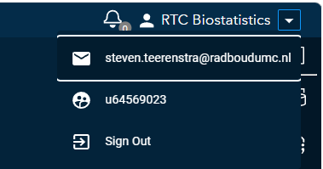

Open shared program
- You can click on the triangle left of Files (Home) to see a file:

- Double-click to open.
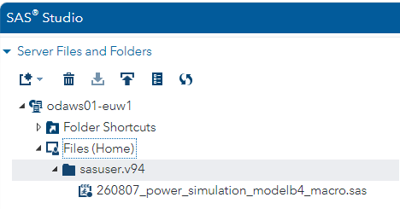

- Select the part of the program that starts with **** beginning of macro’s ***** till ***end of macros ****
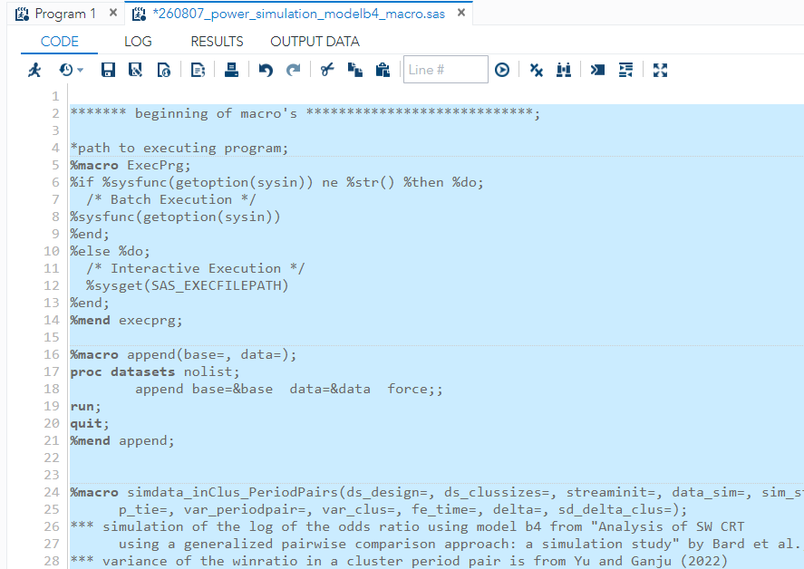

…
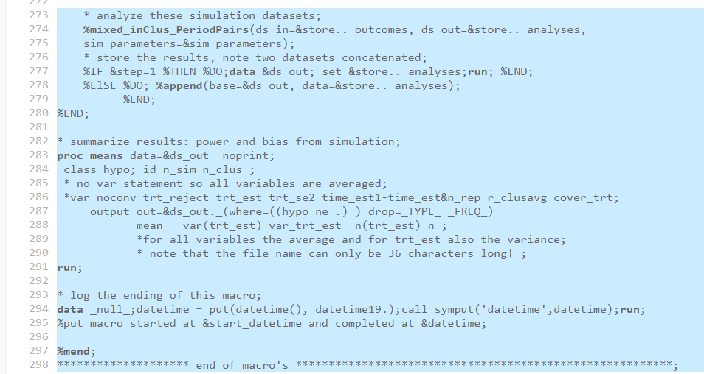

- Run it by clicking on the ‘running man symbol’
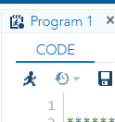
- You then end up in de LOG tab (this gives the messages whether things went well or not)
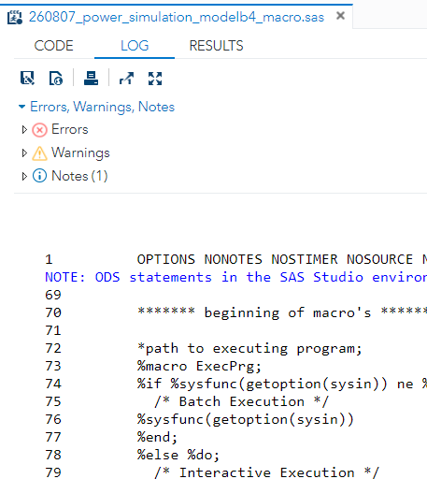
v
- Go back to the CODE tab by clicking it
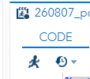
v
- You can specify your input with the design: the design matrix (rows are clusters, columns are periods):
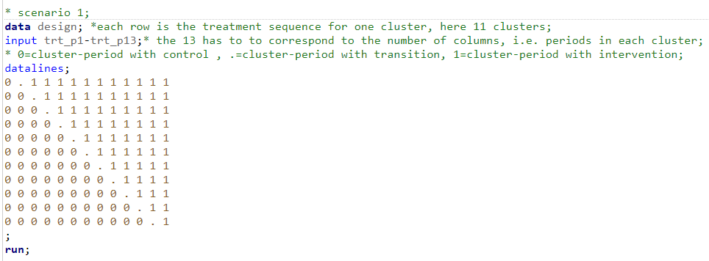
- The number of patients per cluster-period:
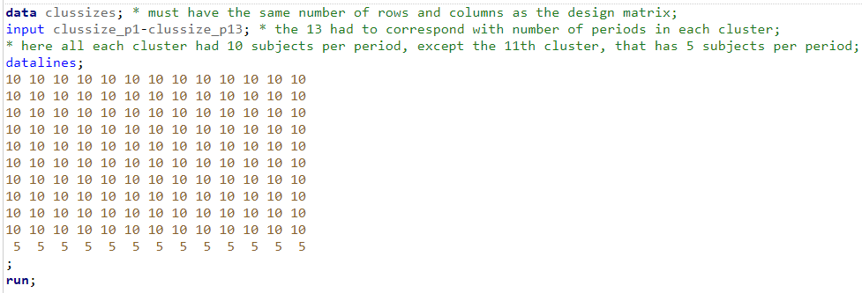

- And the simulation parameters:
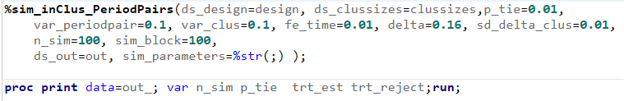

- You can select all these and then ‘run’ (the running-man-symbol)
- The program will run:
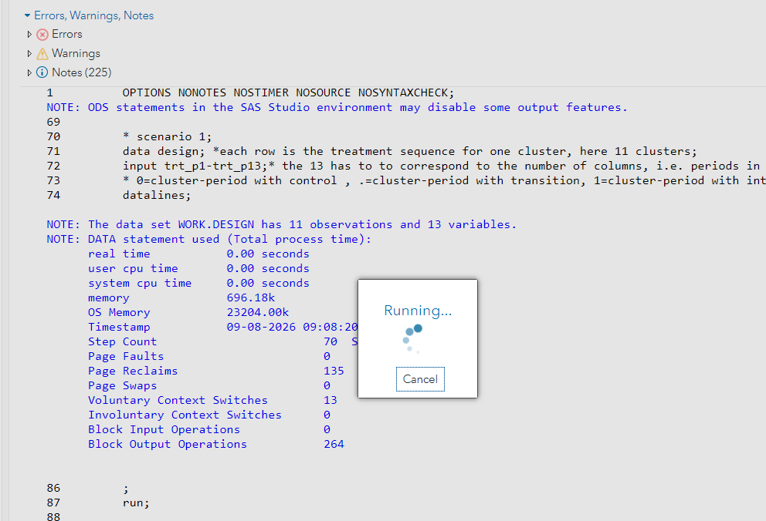
- And finish in the RESULTS tab
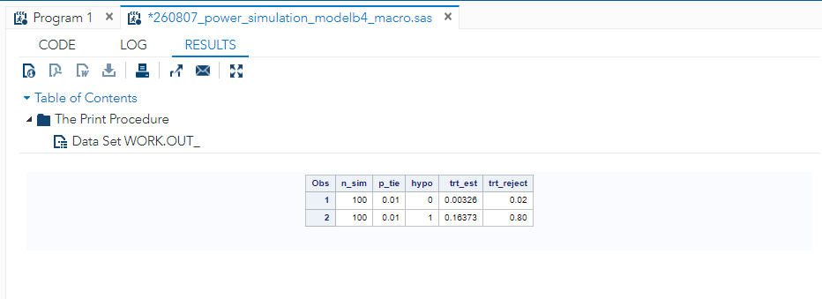(Apparently: a type I error of 0.02 and a power of 80%).
v
- We can go back to the CODE tab for the program
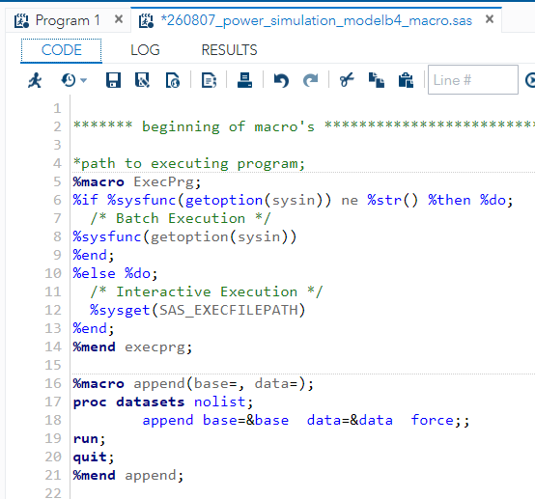
- And specify other designs/sample sizes/other simulation parameters:
Note that comments (that are not executed) are between “*”and “;”

- Save if you are satisfied before logging out.

Appendix: Working with SAS studio
Basically you are working on a UNIX server where you run SAS.
You have your own home directory ( /home/u<userid>) where
- you can make directories,
- store (and upload and download) dataset,
- make and run sas programs, and
- save (and download) output files with results, figures, tables etc.

Making a (sub)directory for your work / project

In the right panel click your main folder (“Files (Home)”),
you can create a new folder by the right-clicking and in the menu select “New” and “Folder”.
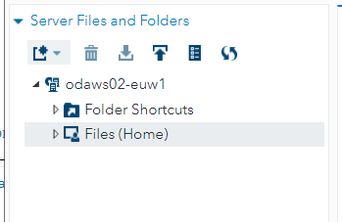 | 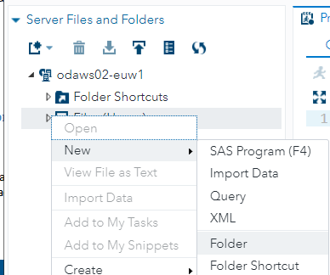
and give it a name
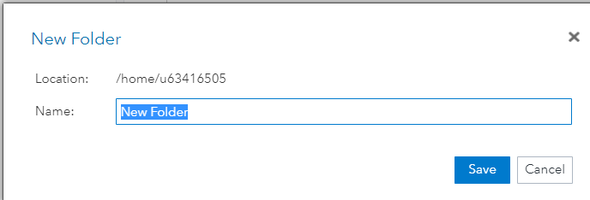

Finding the path on the server to a directory (to refer/save files with a libname statement)
Right-clicking on the file or directory and in the menu choose “Properties” shows you the filepath

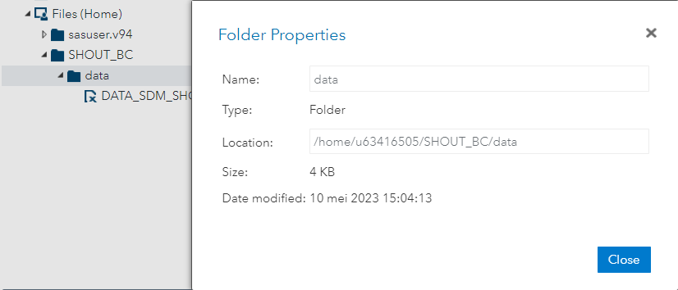

So you can make statements like
libname dir “/home/us63416505/SHOUT_BC/analysis”;
and then use relative file paths like
libname data “../data”;
when your current directory is dir and you want to refer to the directory “/home/us63416505/SHOUT_BC/data”

Uploading to directories and downloading files
Select the *folder* to upload a file to
or
select the *file* to download.
There are at least two ways:

Option 1: Via the buttons in the upper left
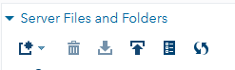

Option 2: Right-click:
After selecting a *directory* to upload:  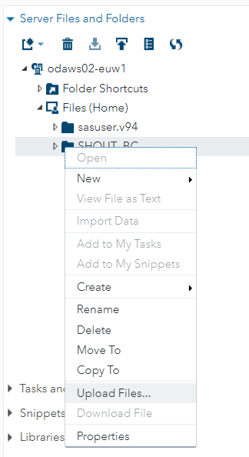 | After selecting a *file* to download:  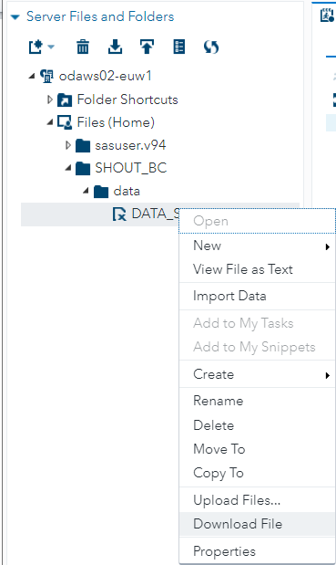

Reading a data source (Excel, SPSS, STATA, …) into SAS
After uploading the data file, select it a right click:
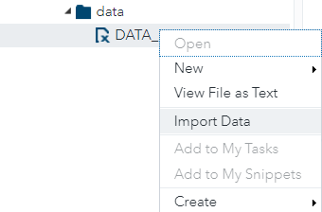

In the right panel, a program to read the data will be generated (on the bottom):
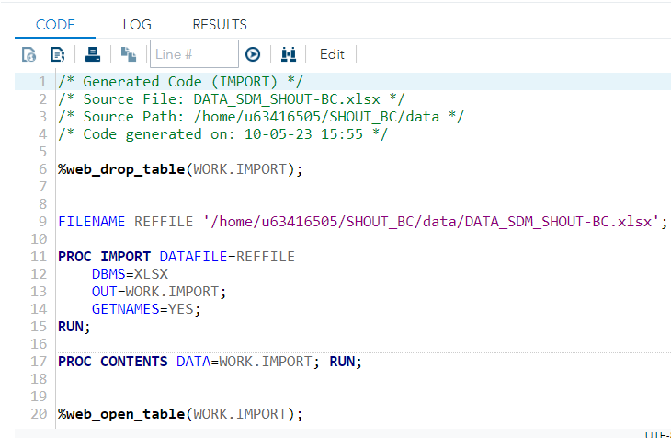
In the top right window, some meta information on the program will be given, e.g. options used.
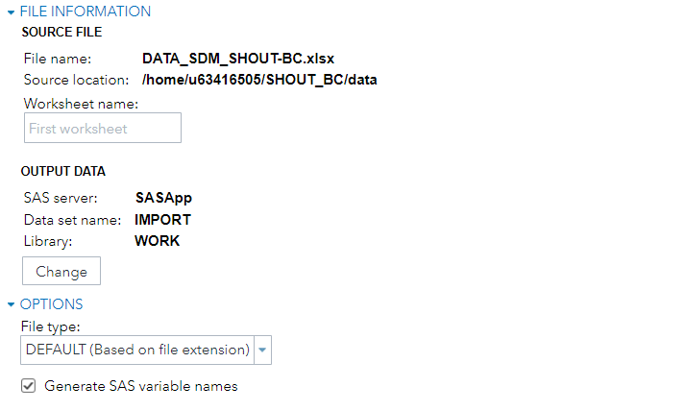

The program still has to be run (select and then F3 or the run button):
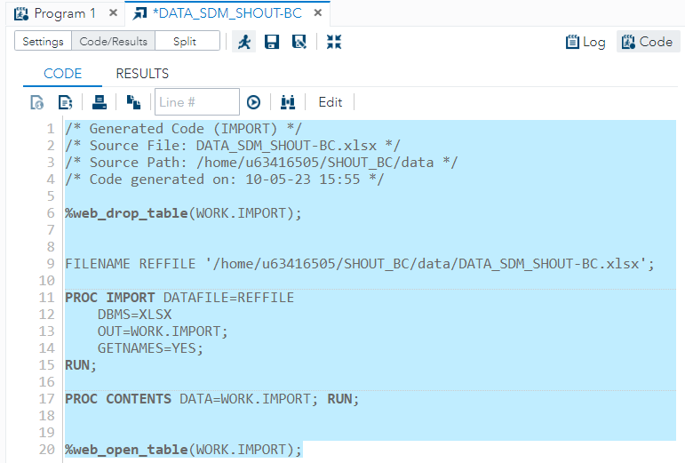

The data is read now but will only be in a temporary directory ‘work’ (and will be lost if you log-out).
This can be seen in the left panel after selecting “Libraries”:
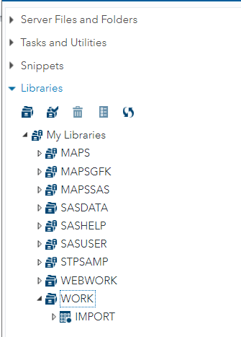
You can double click (here “IMPORT”) to see its contents
Note that also variable information (after selecting it) can be seen (left down panel):
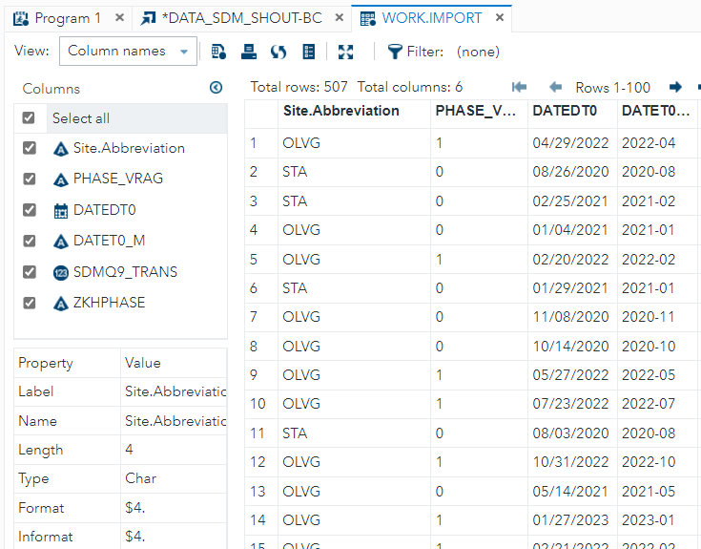

Permanent SAS dataset after reading it from a data source (Excel, SPSS, STATA, …)
To avoid reading the data from source every time one logs in, we can make it into a permanent dataset.
For this we need
- a folder (here we use the “data” folder we created as above);
- making some changes to the import program created above
We go to the import program made above and click the “CODE’ panel and then click “Edit”:
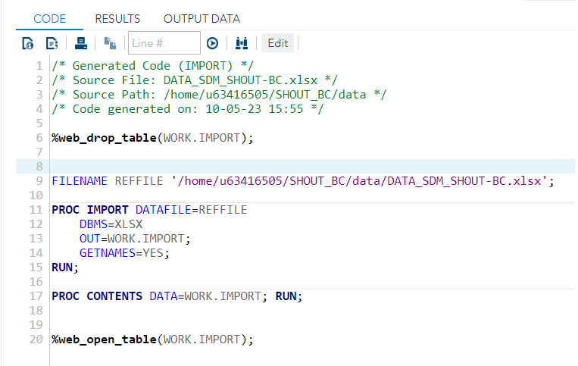
We change it to (highlight):
****
LIBNAME data '/home/u63416505/SHOUT_BC/data'; * reference to a directory;
FILENAME REFFILE '/home/u63416505/SHOUT_BC/data/DATA_SDM_SHOUT-BC.xlsx';

PROC IMPORT DATAFILE=REFFILE
DBMS=XLSX
OUT=data.shout_bc; *choice of sas permanent data file;
GETNAMES=YES;
RUN;
******
Note that libname uses an absolute path (/home/u63416505/ is the home directory).
Note that the ‘libname’ data is used in the OUT statement and we made a choice for the name of the dataset (here “shout_bc”).

We run the program by selecting the programming lines and then press F3 or use the ‘run’ button .

In the left panel -> Libraries , we can find our dataset back

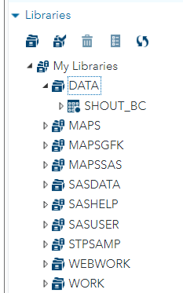

For completeness, we save the import program (although we would not need to import the data again, as it is permanent now). That can be useful when another source file is uploaded and we want to overwrite the current permanent dataset.
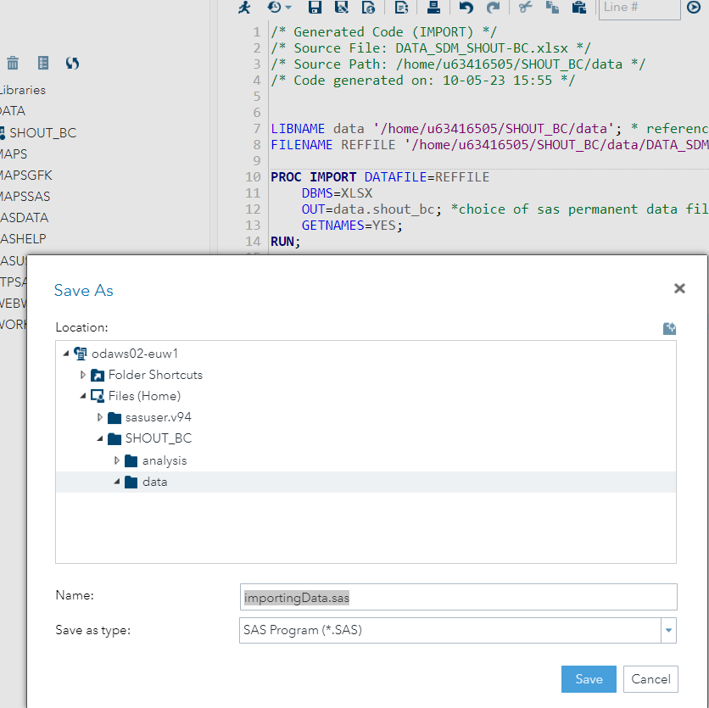

In the left panel-> Server and Folders, we can find now our import program back:
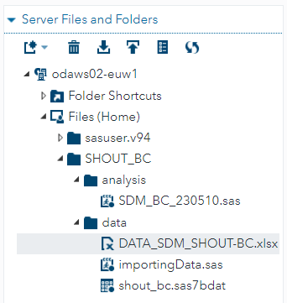

Referring to directories (for data or format libraries) using library names
Library names can be assigned using the most left symbol (the file cabinet):
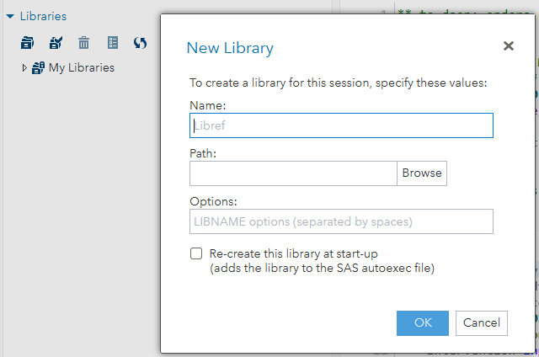

Making a new program
First select the folder where you want the program in (here “analysis”) in the left panel -> Servers and Folders:

Via the folder and righ click:
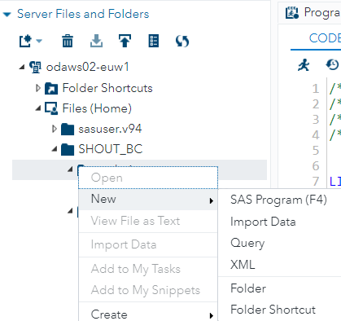

via the right panel and right click:
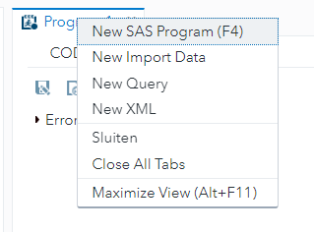

via pressing F3

Running a program and seeing the output
We run the program by selecting the programming lines and then press F3 or use the ‘run’ button .

Hiding and unhiding the left panel (with Server Files and Folders, Libraries etc).
Use the symbol:

in the righ panel:
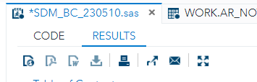

Program, Log, Results window open next to each other
The several windows can be viewed together by dragging them and releasing them.

E.G. left click on the log panel on top:
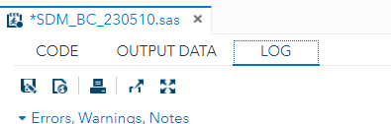

Then drag it (you see the red marking):
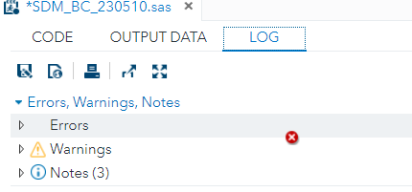
Release when you see the green marking


For example, you can thus create a left-up, left-bottom and right-panel (e.g. a CODE window left up (with an extra tabl for “OUTPUT DATA”), a LOG window right, and a results on the bottom).
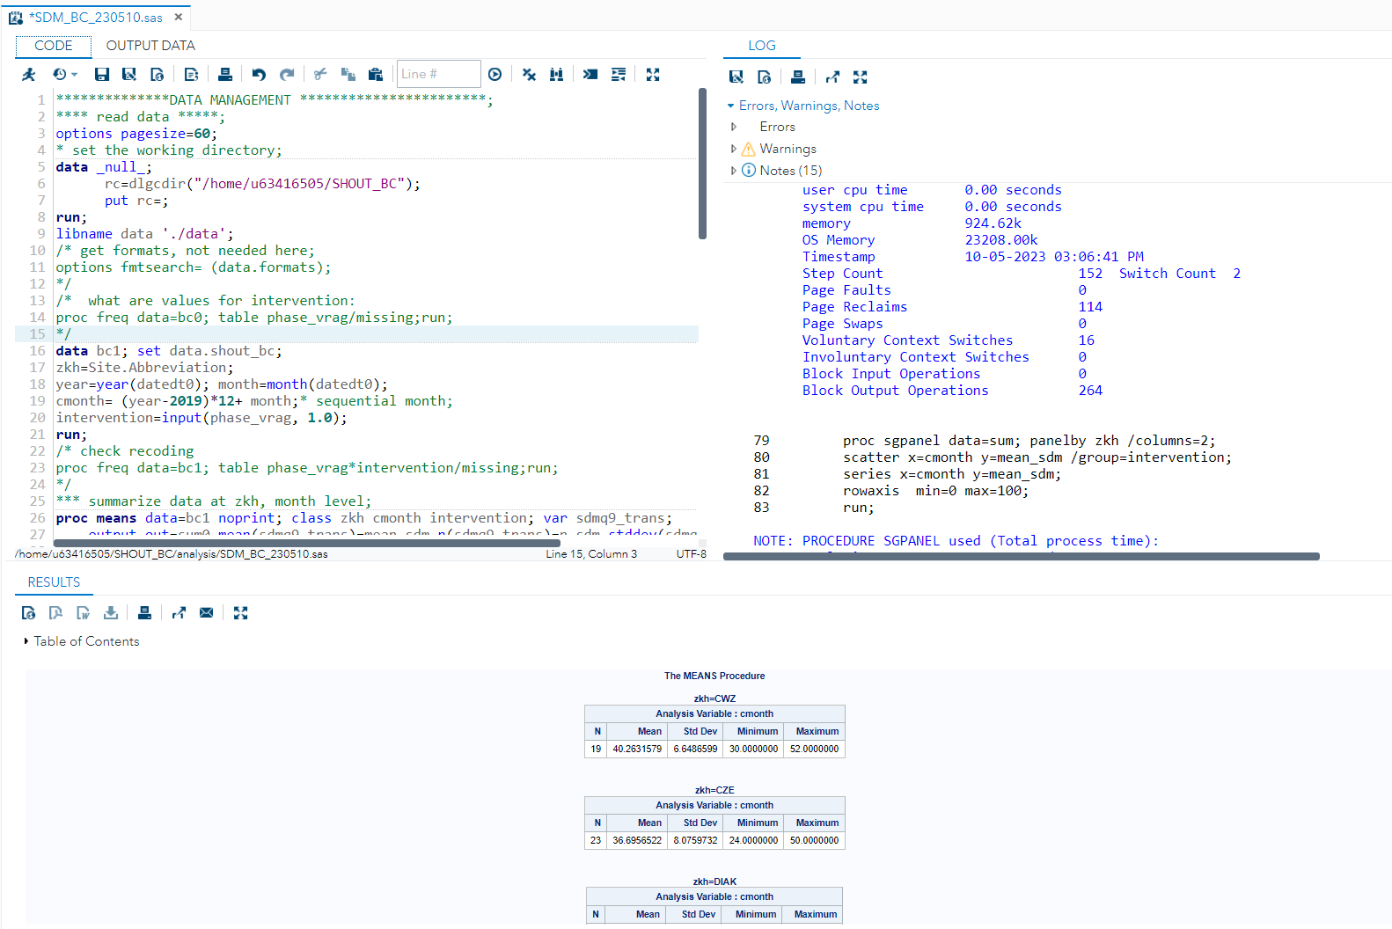

You can use ALT-2 or arrow-keys for switching between tabs within a ‘window’ e.g. “CODE” and “OUTPUT DATA” in the top left window.

Also separate browser screens can be used (by ‘pulling’ a tab off the browser screen it is in)

See also:
https://communities.sas.com/t5/SAS-Software-for-Learning/Viewing-the-editor-log-and-ouput-windows-simultaneously-on-SAS/td-p/846626

See also:
https://communities.sas.com/t5/SAS-Communities-Library/SAS-Studio-tip-How-to-Layout-Tabs/ta-p/476111

Creating pdf, rtf output or figures (these can be downloaded as indicated above)
* saving as an rtf file;
ods rtf file== '/home/u63416505/SHOUT_BC/results/output.rtf';
…(procedures to be output)…
ods rtf close;

* saving it as a jpg file;
ODS GRAPHICS / RESET IMAGENAME = 'Final' IMAGEFMT =JPEG
HEIGHT = 2in WIDTH = 3in;
ODS LISTING GPATH = '/home/u63416505/SHOUT_BC/results' ;
*
…(code for the figure to be output)..
ODS GRAPHICS /RESET;

* saving it as a pdf file;
ods pdf file="/home/u63416505/SHOUT_BC/results/sgpanel.pdf";
… (code to be output) …
ods pdf close;

see also the internet, e.g., https://www.mwsug.org/proceedings/2010/how/MWSUG-2010-51.pdf

Making comments within a program (comments are not executed)
Text between “*” and “;” (suitable for commenting our one line) or between “/*” and “*/” (suitable for commenting out several lines).

Shortcuts
(https://communities.sas.com/t5/SAS-Communities-Library/SAS-Studio-tip-How-to-Layout-Tabs/ta-p/476111)
F3 for running a program
ALT-2 or arrow-keys for switching between tabs within a ‘window’

